5) Implementation strategy including Architecture of the system (5 marks).

**Architecture of the system**

“System design is the transformation of an analysis model into a system design model. During system design, developers define the design goals of the project and decompose the system into smaller subsystems that can be realized by individual teams.” (Bruegge and Dutoit, 2010). A subsystem provides services to other subsystems, it has two properties, coupling and cohesion. A good system design should reduce system complexity while allowing change. To do that, we need to minimize coupling and maximize cohesion. Pearly Gates Cemetery and Crematorium Information System will be based on **Model-View-Controller** architectural style. The subsystems in this model are classified into three different types, *Model subsystem*, *View subsystem* and *Controller subsystem*.

Model subsystem maintains the domain knowledge (Data) and does not depend on the controller or the view. The model also represent the business rules used to manipulate the data.

View subsystem is an interface to view and modify the data using text boxes, buttons, and checkboxes. This subsystem also sends user actions such as button clicks to the controller.

Controller subsystem is the mediator between Model and View subsystems. It provide model data to the View and manage the sequence of interaction / operations that can be performed on the data with user. Controller interprets user actions such as keystrokes, mouse movements and button clicks.

Considering the independency of the Model Subsystem, this architecture accommodates future changes to View and Controller subsystems without having to modify the Model subsystem. For example, employees with having access to data using their own devices need different control and view options to the one provided for managers, furthermore, in future the company can improve the user interface by adding more features to it without restructuring the whole data. Therefor we recommend to base Pearly Gates Cemetery and Crematorium Information System on MVC architectural style.

**Implementation strategy**

“Object design closes the gap between application objects identified during requirements and off-the-shelf components selected during system design.” **(***Bruegge and Dutoit, 2010***).** Object design includes four group of activities: *Reuse, Interface specification, Restructuring, Optimization.*

Reuse activities solve the conflict of defining a stable architecture but allowing flexibility to deal with change in the future development process. Different design patterns can deal with number of different anticipated changes such as changing vendor who provide devices used by Pearly Gates Cemetery and Crematorium’s employees or managers. In today’s dynamic environment change is inevitable and so is the technology, upgrading technology to keep up with the fast paced environment is very common.

Therefore, to satisfy the future needs of upgrading the commercial components used to build the system, also assuming that employees has their own devices which can be used wirelessly while connected to a local or mobile network, and the need of being able to deal with future updates and future network protocols without having to recompile the application, the appropriate design pattern for Pearly Gates Cemetery and Crematorium Information System is the strategy pattern. This pattern is also suitable with the MVC architecture style, both the MVC and strategy pattern insist minimum coupling and maximum cohesion.

In Strategy pattern, we create objects which represent various strategies and a context object whose behaviour varies as per its strategy object. This pattern decouples an algorithm from its implementations and encapsulates a behaviour. (lecture 09).

6) Design a user interface for ONE of your use cases (5 marks).

User Interface for Order Coffin use case.

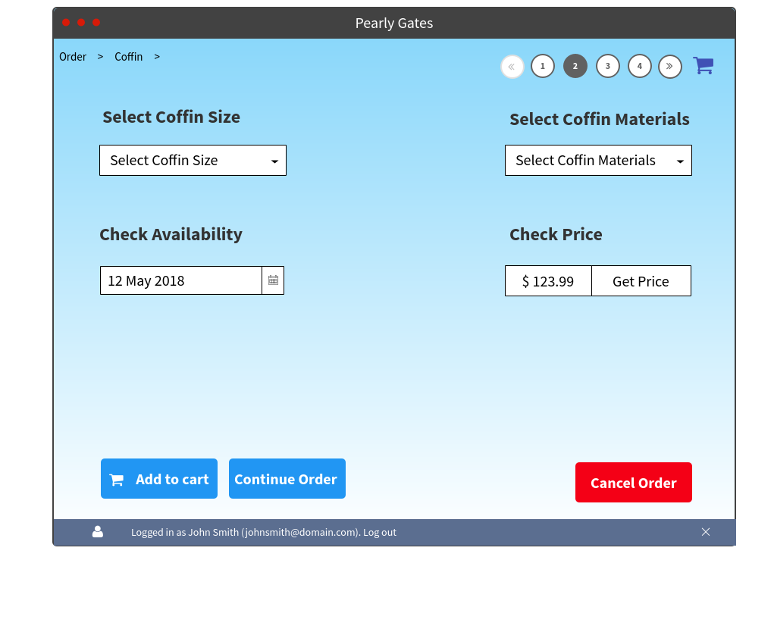

References:

Bruegge, B. and Dutoit, A. (2010). *Object-oriented software engineering*. Boston: Prentice Hall.